Low-Fidelity Prototype & Evaluation Report

IDK PRO

Gong Cheng

Kasey Gillespie

Kaitlyn Gorsalitz

Halle Jackson

Low-Fidelity Prototype & Evaluation Report

| Gong Cheng  U of S  Saskatoon, Canada  goc558@mail.usask.ca | **Kasey Gillespie**  U of S  Saskatoon, Canada  kag258@mail.usask.ca | Kaitlyn Gorsalitz  U of S  Saskatoon, Canada  krg028@mail.usask.ca | Halle Jackson  U of S  Saskatoon, Canada  hsj294@mail.usask.ca |
| --- | --- | --- | --- |

# FUNCTIONALITY

DeviantArt is an art sharing website that allows users to create an account, upload pieces of art, view other users’ works, favorite other users’ art, and follow other artists. For our project we have chosen to redesign components of the DeviantArt website. Specifically, we have changed the page in which a user views a single work of art, added a history tab to view works that a user has looked at recently, redesigned the search domain, and added new functionality to the browsing screen which allows users to select multiple works to view in a streamlined way. We put great efforts into making the art sharing experience on DeviantArt as enjoyable as possible by radically changing the current interaction model.

# Prototype

## Overview

For our low-fidelity prototype evaluation we adopted the paper prototype method. We have three essential ‘views’ in the prototype, the first of which is the Browsing View. The Browsing View is the main view seen when a user is searching for art, and is represented in the prototype by a large sheet of paper with multiple rectangles drawn to represent the works of art. The second view is the Queue List, which is placed over top of the browsing view as it acts as a sidebar and header to this view. The Queue List is where the search information is displayed, and the items belonging to the queue of art to be viewed is shown. Our final piece is the viewing area for art, which is meant to be laid on top of the Browsing View, as this screen appears in the foreground overlaid above the other views. This can be changed to represent viewing a single work, or to represent viewing a queue of works. We used the Wizard of Oz approach to demonstrate the change between these views. When in Queue View, sticky notes representing left and right arrows are added to the art viewing area, and a large colored piece of construction paper is placed in the white space above the artist information to represent the main piece of art currently shown, while smaller ones are placed behind it on either side to represent the other works of art in the queue that you can see by moving forward or backward. When in Individual View, the arrows are removed and only one piece of art is present in the viewing area, represented by the largest colored rectangle.

We used colored paper to represent drawings that the user could browse for. In the Individual View and Queue View the pieces of construction paper are used to represent art. In the browsing view, sticky notes are used as the art thumbnails to allow us to move them to the queue. There are only four thumbnails that are able to be added to the queue; the number of interactive parts was limited to simplify the scope of the prototype.

## Reflections

We had an initial meeting to discuss the design, and each of us came to the meeting with different scribble sketches of individual ideas. We presented our own ideas one by one, explaining our sketches and answering questions about them. After all ideas were demonstrated, we discussed the pros and cons of each one. There were roughly 8 main concepts tossed around. After around two hours of discussion we combined ideas from multiple approaches and determined that our design would involve a queue sidebar that different works could be added to and removed from, the question was how would the art be added to this queue. Two main concepts were talked about:

1. The “Bubble Up” approach. The works on the main browsing screen would not remain static for a user to scroll through, and instead new art thumbnails would constantly be animating up in a revolving view. The user would pick works to add to the queue by clicking on the thumbnail, which would “pop” the “bubble” and add it to the queue, removing the thumbnail from the revolving view. [See Figure 1 in Appendix A]
2. A simpler approach. Each thumbnail in the main browsing screen would have a “+” button on it that, when clicked, would add that piece to the view and change the button to a “-”. [See Figure 2 in Appendix A]

The second approach was chosen, as the first was deemed too difficult to pursue and potentially irritating to the user. Once that was chosen a full design for all screens based on the concept and scribble sketches was drawn out on a whiteboard by one member, while the other teammates pitched in with feedback. From that basis the design for the paper prototype was developed. [See figure 3-5 in Appendix A]

We decided on a fairly limited scope for the prototype, focusing on the main tasks of adding art to a browsing queue, and viewing the art after, or viewing it in individual mode. There were several screens discussed and designed that were not implemented in the prototype. One was a history screen that was determined to be similar enough to the main browsing screen that it was unnecessary to prototype. Another was a more advanced search option that was decidedly out of the scope we determined.

**Usability Inspection**

**Inspection method**

We went with the Heuristic Evaluation method for our usability inspection, because it is what our members are the most familiar with, works well with a group of our size, and is holistic. A Heuristic Evaluation, using heuristic guidelines to evaluate the usability of strict paths through the product, fit well with the scope of our prototype. As well, the initial individual approach of a heuristic evaluation fit more with our schedules at the time than a group inspection like the Formal Usability Inspection.

## Tasks

* View an individual work of art.
* Add art to the queue, remove art from queue, and view art queue.

## Inspection Process

The inspection was conducted individually by all four teammates, as three to five people are recommended for a heuristic evaluation. Two major tasks were identified as being the most basic or most important in terms of user experience for our redesign. We each set aside about an hour and walked through both tasks individually using the paper prototype while referencing the heuristics. We tried our best to approach the task as a first time user and to be very picky so that any potential flaw could be captured. We each wrote up the usability issues we discovered, and then came together to discuss them as a group. We amalgamated the remarks into a list and ranked them by severity. There were several items that were not really issues and were more discussion topics, but we left them in our combined evaluation with the severity of 0 so that we would have a record of the items discussed. To determine the severity of each usability problem, we talked over what we each thought it would be, and then decided on it as a group.

**Results of inspection**

The inspection both provided us with new concerns over the given functionality of the prototype, and provoked discussion of other functionality we initially overlooked when designing. Overall we found many potential usability issues, some of which were just noted by one evaluator, others were shared by several, and we combined these issues into a list. The full list can be seen in Appendix B, but some highlights are:

* There is no way of tracking which works in the queue have already been viewed if you leave the queue and return to browsing view.
* The close button (“X”) in the art viewing screens is not that visible, and is placed in a way that it may lead users to believe that we are just closing certain sections of the view, not all of it.
* There is no way to transition from Queue View to Individual View if one wants to focus more on a specific piece.
* The “add to favorites” and “remove from queue” buttons are on top of the thumbnails in the Browsing View, but to the side of the thumbnails in the Queue List, making for an inconsistent appearance.
* The Queue List is taking up a lot of space that could be better used.
* There is no option for clearing all works out of the queue, which could lead to a potentially frustrating user experience.
* Some section titles such as “Also liked” and “Other works” have meanings that are not immediately obvious.
* In Browsing View, if a work has been added to the queue it does not pop out, and should be more obvious.
* The arrows present in the Queue View which move to different works in the queue may be extraneous and unnecessary since we can also click on the works displayed behind the main one.
* An empty queue is potentially confusing, and should instead inspire users to add to it. As well, there is no extra information as to what the queue is to help inexperienced users.
* A user is not able to remove art from queue while in Queue View. This would be helpful if a user is looking through other art as a reference, and decided there were a few they were done with and wanted to remove.
* A user who has no interest in the Queue List should be able to collapse it from the view.
* There is some empty space that is not used to its full potential.

**REDESIGN**

Going through our different tasks helped to inform us of how different users may go through the system, which in turn led our redesign conversation. Going over our amalgamated evaluation list, we highlighted several things that we will need to modify or add in the medium-fidelity prototype.

* We will add a way of indicating which works have already been viewed in the current queue if the user goes back to browsing mode by adjusting the thumbnail in some way.
* The close “X” button in Single View/Queue View will be moved to make it more obviously associated with the whole overlay, and more visible.
* The Queue List section will be reorganized so that the thumbnails of queued works will match how the thumbnails are laid out in the other sections.
* A “Clear All” option will be added to the Queue List.
* There will be several small text changes to make the intent of different sections more obvious, i.e. “Other works” to “Artist’s other works”.
* The thumbnail, or the “add to queue” and “remove from queue” buttons on a thumbnail, will be modified as to be more obvious at a glance if a work was already added to the queue.
* The browsing view will be paginated, and need some indicator of this pagination.
* When the Queue List is empty we will add a message encouraging users to add to it.
* Proportions and spacing will change in the Individual View or Queue View to better highlight main piece shown.
* We will add a way to remove art from the queue when in Queue View.
* Information as to what the Queue List is will be added as help documentation in some non-obtrusive way, for users who don’t understand it.
* There will be changes to layout and proximity as to better use the space.

­­As well, other questions raised during our evaluation phase will be discussed, and we will determine other additional changes to be made. ­­

**APPENDIX A: The sketches made to prepare the paper prototype**

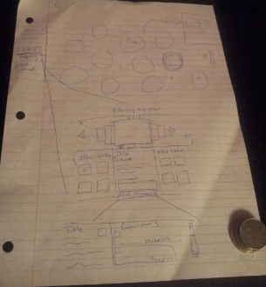

Figure . A scribble sketch of the “Bubble Up” design. Works (represented conceptually as bubbles) rise up and the user “pops” them to add it to a queue of selected works to view.

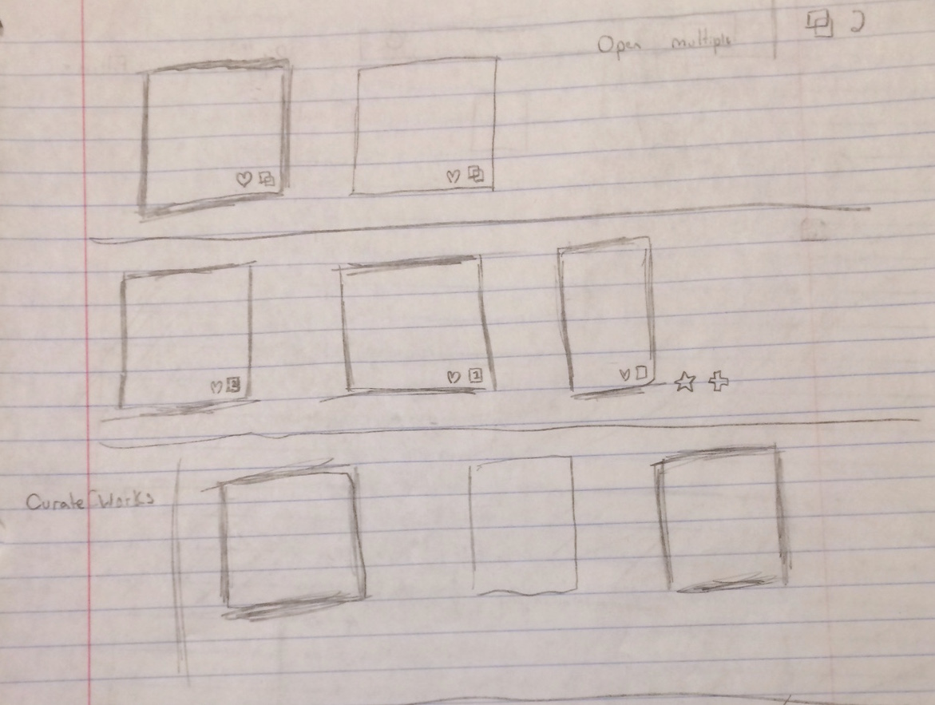

**Figure 2. A scribble sketch of three different ways to select a work to add it to the queue. The first two have icons on the corner that will add it to a queue. In the last one works are added by a right click.**

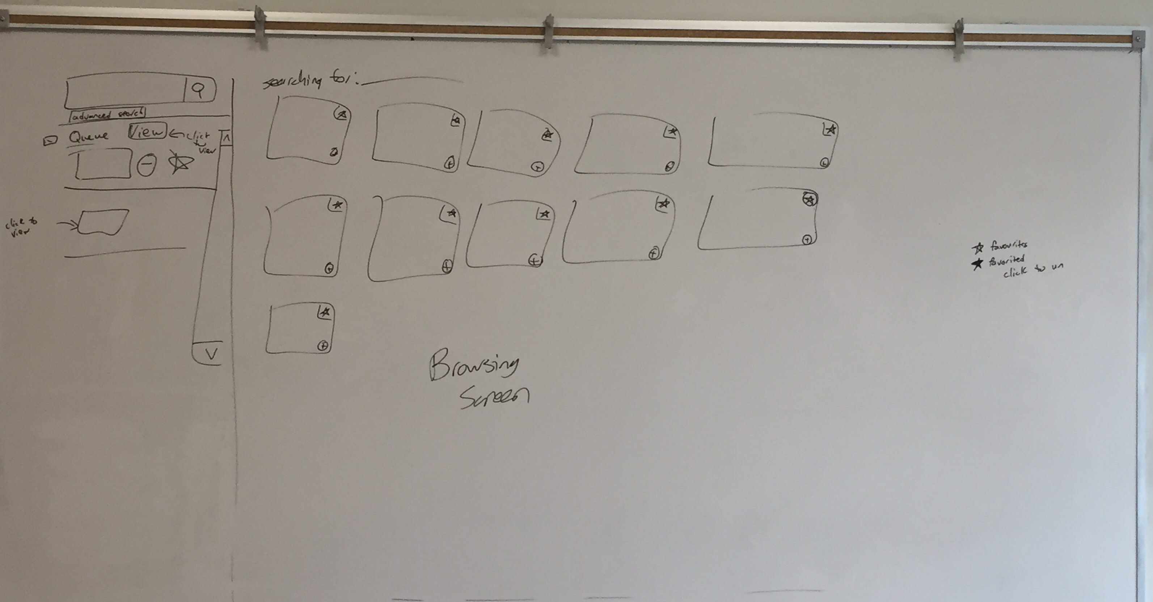**Figure 3. The design for browsing through a list of art. Works are laid out in rows of thumbnails that contain “favorite” and “add to queue” buttons. The “add to queue” button is changed to a “remove from queue” button when clicked, and the work is added into the list of queued art in the sidebar.**

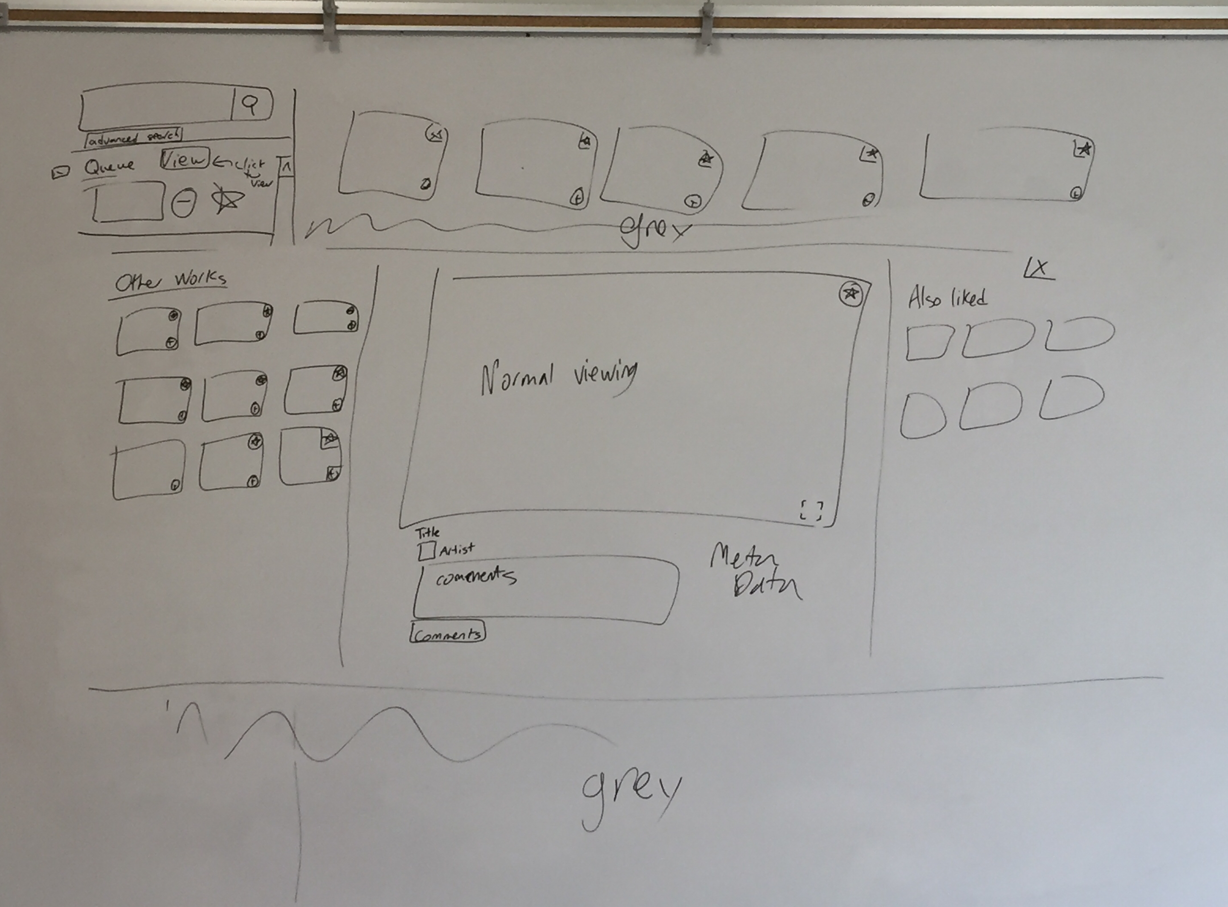**Figure 4. The design for viewing a single work of art. A panel that shows the work and its details appear, and other suggested works are displayed at the sides. It appears over top of the browsing view, which moves into a background.**

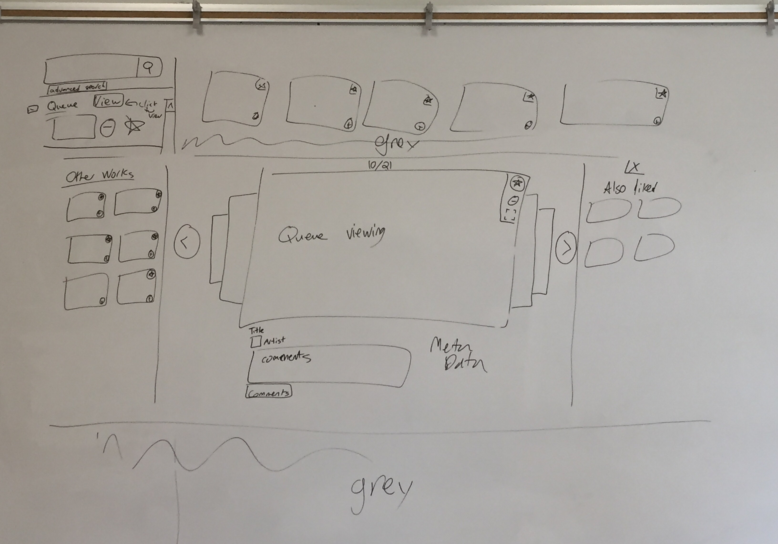

**Figure 5. The design for viewing the queue of works. A panel that shows the works appears, and other suggested works are displayed at the sides. It appears over top of the browsing view, which moves into a background. A user can see different works in the queue by clicking the arrows or the queued art in the background.**

**APPENDIX B: Amalgamated Heuristics**

Browsing View - The main view, showing multiple works of art.

Queue List - The sidebar included in browsing view.

Queue View - The view showing specific art in queue form.

Individual View - The view showing an individual piece of art.

|  |  |  |  |
| --- | --- | --- | --- |
| Location | Heuristic | Severity (0-4) | Description |
| Individual View & Queue View | H2-1 | 0 | Individual View and Queue View are similar, which would possibly be confusing for people with no prior experience of using the website.  > We have decided this is not an issue as it keeps the views consistent and standard. |
| Individual View & Queue View | H2-2 | 0 | The Individual View/Queue View art is missing the favorite button & the comments button.  (Missing as not the focus of prototype) |
| Browsing View | H2-2/H2-3 | 0 | We’ve talked about clicking to add to queue, but would drag and drop work as well?  > Yes but out of scope for prototype |
| Queue View | H2-3 | 0 | It is not clear if the back or forward arrow will still appear when the user is at the end or beginning of the list. Will we allow for jumping to the head/tail?  > Queue view will loop, so clicking next from the last work will take user to first work |
| Queue List | H2-8 | 0 | Border lines are present between the items in the queue. Remove in medium prototype. |
| Browsing View & Queue List | H2-6 | 0 | There’s no scrollbar to indicate where the user is amidst the viewed works. (Already planned out, missing in prototype) |
| Browsing View | H2-7 | 0 | Is the system infinite scroll or will it go by a page by page system? Nothing shows that in the prototype.  > Page by page |
| Queue View | H2-3 | 0 | Can you scroll through art in queue horizontally?  > Yes, but it’s potentially out of scope for the medium-fidelity prototype |
| Queue View | H2-1 | 0 | # of items in queue missing  (Planned but missing in prototype. Should be overtop the queue.) |
| Browsing View | H2-3 | 0 | Will the queue stay from search to search, or be erased?  > Queue will stay until cleared. |
| Queue View | H2-3 | 0 | Does adding to Queue while already in Queue View add the art?  > New art is added to the end of the Queue |
| Queue List & Queue View | H2-7 | 0 | Does the “view” button for the queue ALWAYS start at the first entry? Should there by “view” buttons for each entry to start there?  > Clicking on the image thumbnail in the Queue List will open it as the first in the Queue View |
| Browsing View | H2-3/H2-8 | 1 | Can we collapse the queue sidebar?  > Yes |
| Queue List | H2-2 | 1 | The favorite icon is missing from works in the queue. (Planned but missing in prototype).  > Added to prototype |
| Individual View/Queue View | H2-4 | 1 | The queue view column is replaced by “other works” view when switching from browsing view to queue view.  > Remain as is, queue is part of the shadowed background. |
| Individual View & Queue View | H2-7 | 1 | The close button (“X”) is not that visible in the prototype.  > Button will be moved to outside of Single View/Queue view section, and be more obvious with color. |
| Browsing View | H2-4/H2-8 | 1 | The add to/remove from queue and favorites button are in a different spot in thumbnails in queue and main browsing view. Also there is a lot of whitespace in queue.  > Buttons will be laid on top of thumbnail in queue to match how they are laid on top of thumbnail in main browsing view. |
| Queue List & Queue View | H2-1/H2-4 | 1 | # of items in queue not visible in Queue List, while they are in Queue View  > Number of items in Queue List will be added |
| Individual View & Queue View | H2-4 | 1 | “Also liked” doesn’t fit with DA’s terminology of “favoriting”.  > Change to “Others favorited” |
| Individual View | H2-1 | 1 | “Other works” wording not entirely clear  > Text change to “Artist’s Other Works” |
| Browsing View | H2-4 | 1 | “Searching for: [word]” and “related tags” may not be immediately apparent. Could word as “Searching for tag [word]” or “related searches” instead? |
| Individual View & Queue View | H2-8 | 1 | More focus should given to main art piece, smaller thumbnails.  > Smaller thumbnails, less white space. Measurements are off in low-fidelity prototypes. |
| Browsing View & Queue List | H2-5 | 1 | The + and - queue buttons should be different colors to make it easier to tell them apart.  > Button colors will be changed |
| Browsing View | H2-5/H2-6 | 1 | The +/- buttons could be bigger - it could end up easy to go into the individual view rather than add/remove the picture from the queue. A border around works added to the queue could also help?  > Border may be added |
| Queue View | H2-8 | 1 | Arrows become redundant as the thumbnails of previous/following works are shown and the users could just click those instead (and in addition skip ahead/back more than just one)  > Potentially removing arrows, or adding them on top of works in the background. |
| Queue List | H2-10 | 2 | A button such as “what is this?” or even just “?” could be good in the queue list area so people could click it if they need to know how to use the queue. Information button.  > Queue info icon or tooltip will be added |
| Queue List | H2-10 | 2 | When the queue is empty, in its space it could perhaps have the message “Press the + button on any piece you like to add it to this queue to make a more personalized viewing experience!” Otherwise plus button not entirely clear that it corresponds to the queue.  > Message will be added to empty queue area, encouraging users to add works to it |
| Individual View & Queue View | H2-3 | 2 | Paper prototype makes it hard to show that a user can add items to their queue from the ‘Other works’ and ‘Also liked’ Sections  > ‘Other works’ and  ‘Also liked’  thumbnails will have the “add to queue”/”remove from queue” buttons in the Medium Fidelity Prototype |
| Individual View & Queue View | H2-5 | 2 | The X to get out of the view almost looks like an option to close just the “also liked” portion since it’s in the same area. Not obvious it’s for all view.  > Move X to outside Individual View/Queue View area. Clicking outside the area closes it as well. |
| Queue View | H2-3 | 2 | Can’t remove art from queue when in queue view  > Add remove icon to view. A dialog confirmation will appear when clicked, and if confirmed work will be removed. If you remove all works, it kicks you out to browsing view. |
| Individual View & Queue View | H2-7 | 2 | No obvious way to go to single view page from queue view page. |
| Browsing View | H2-6 | 2 | There is no way of tracking pictures in the queue that have already been viewed if you leave the queue.  > Thumbnail or thumbnail border will be darker if art was previously viewed in queue. |
| Queue List | H2-7/H2-3 | 3 | No option for removing all from queue  > Clear queue option will be added. |